O A K H I L L M I D D L E S C H O O L

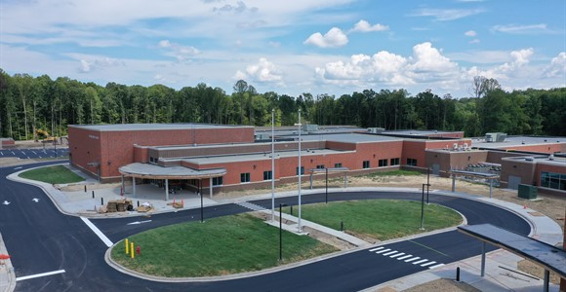
S U C C E S S D A Y
September 11, 2019

A G E N D A

WHERE WE’VE BEEN IN THE WORK
Overview of our work at this school
- Share out highlights of FYS work during seven last years
- Recognize the high points and the low points
- Give specific examples of matrices done here at CMS/OHMS
- Relate matrix work to PBL development
- Discuss the “WHY”
- Rationalize the instructional value of this work

SUPPORT GALORE
Forms, Support, and Procedures
- Support website- https://ohmsteams.com
- Matrix template
- Cornerstone Skills
- DOK levels
- Standards
  - Deconstruct Standards
  - Standards based instruction
  - Standards driving PBLs

BRAINSTORM WHAT WE CAN ACCOMPLISH
Needs, goals, dreams, and focus
- Higher order thinking skills
- Common expectations
- Common formative assessments
- Cross-curricular lessons
- Peer to Peer visits
- Differentiate
- Community Connection
- PBL design, implementation, and impact
- Realize the dream

