Smithsonian Institute Virtual Tours

https://naturalhistory.si.edu/visit/virtual-tour : this will take you to the Smithsonian website
You could have kids write in response to taking a tour or create any content based lesson based on the tour.

Available Tours

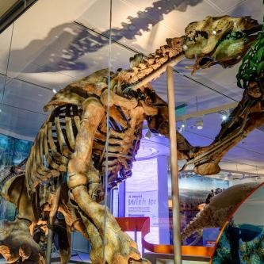
Permanent Exhibits

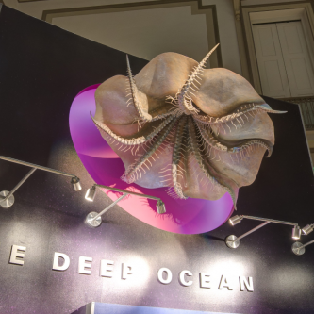
Current Exhibits

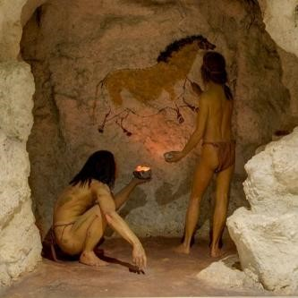
Past Exhibits


Museum Support Center & Research Stations

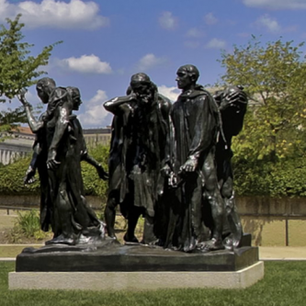
A Few Other Smithsonian Tours

